

**PROBUS CLUB OF ARARAT**

**Incorporation #A0003724B.**

**NEWSLETTER- June 2025**

**ISSUE 201**

**P.O. Box 258, Ararat 3377** [**www.probusararat.com**](http://www.probusararat.com) **Secretary Ann 0417328631**

**Email: a.sullivan3@bigpond.com**

Greetings Probians. Welcome to the June Newsletter. I trust the Newsletter is finding you keeping well!

**PRESIDENT Ian’s REPORT**

Hello fellow Probians.  Summer is a distant memory and Autumn ,with its beautiful weather is over. Unfortunately, very little rain for the farmers. Hopefully some is on the horizon. Fingers crossed.

Terry and I decided to take a few days in Port Fairy whilst the weather was good. Decided to have a meal at the Caledonian Hotel (The Stump)  which is I believe the oldest continuously run hotel in Victoria.  It certainly is a small world as who was at the table next to us but Rhonda and Roger Spratt who had spent a week down there. A great place to charge your batteries.

Hopefully at our June general  meeting we will have a good turnout to hear our guest speaker, Superintendent Sharon McCrory who will talk on "A life in Policing ".  I'm sure it will be an interesting talk.

Our numbers will probably drop off a little over the next few months with Victorian Probians (Mexicans) travelling north over the border to warmer climes. Safe travels to you all and we look forward to catching up and hearing of the lovely warm weather up north.

Ian Holwell

President

**APOLOGIES**

Tobe phoned or texted prior to the meeting to Secretary Ann on 0417328631

***WHERE THE BLOODY HELL ARE WE***





The location of our clubs annual caravan trip is always a source of intrigue and speculation amongst members.

Well, this year the Camps Committee are going to run a contest for Probians to enter and guess the location of the 2026 camps trip.

A very nice prize will be on offer for the Probian who correctly guesses the location of the camp. The boiled lollies consolation prize will go to the Probian who has no idea and whose guess is furthest away from the camp within the same state.

Just a few guidelines and entry rules,

* Competition open to any fully paid up Ararat Probus Club member
* No restriction on the number of entries per member, but each entry can only have 1 location guess on it
* If more than 1 correct guess received the winner will be determined whose entry is the earliest received by the camps committee.
* If no winner, a consolation prize will be awarded to the member whose entry is the closest to the winning location according to Google maps.
* A city, town, village etc has to be nominated not a region.
* Competition not open to the Camps Committee.
* Competition will open 10.00am June 12th (General Meeting)
* Competition will close 10.00am September 11th (General Meeting)
* Entries returned via email, text or by dropping your entry into the entry box at the general meetings.

Best of luck and get those entries in !!!!!!!!



**ENTRY FORM IS A SEPARATE ATTACHMENT WITH THIS EMAIL**



**CLUB SURVEY**

As part of the continuance improvement process of the club, the Management Committee will be conducting a members survey. The survey is the opportunity for club members to provide feedback back via the survey. You will have the opportunity to comment on a number of aspects of the club. Your survey feedback will be valuable for shaping the direction of the club in the future, catering to the interests of club members in the areas, of club functions, social outings and membership growth, to name a few.

Members will have the opportunity to remain anonymous **OR** place your name on the survey. Those members wishing to remain anonymous will have the opportunity to place their completed surveys in the **return box** or by **return mail.**

Please find the **survey** as an **email attachment** with your e-newsletter **OR** enclosed in your **mail out newsletter.**

We look forward to your contribution.

**Minutes Ararat Probus General Meeting 8th May 2025**

**Present*:*** 50

**Welcome***:* President Ian welcomed everyone.

**Apologies:** Jan Porter, Harry Collins, Helen Molloy, Mark Harrison, Ann Sullivan, Roger & Rhonda Spratt, Ray Hurstfield, Norm Clark.

**Moved** Chris Clark Seconded Rod Mc Clurg Carried

**Guests:** Nancy Mc Clurg introduced Marilyn & Stan Payne.

**Birthdays:** Jeanette Hawley, Laurie Tonkin, Mieke & John Hunt, Joy Cronin.

**Lunch Numbers** 25

Minutes of the April meeting were circulated with the Newsletter.

**Moved**  John Hunt Seconded Glenda Hurstfield Carried

**BUSINESS ARISING:** Nil

**CORROSPONDENCE**

**Inwards Probus South Pacific –** Invitation to the President and Secretary to attend Probus Information sessions in the region during April - May. **Probus South Pacific –**Probus South Pacific board appointments, nominations for Probus South Pacific board & selection committees, how to create a private Facebook for your club, facts about ANZAC Day, Probus Partner Trade Travel – upcoming international departure dates – 2025/2026, message from Probus Partner Coal River Coaches. **Probus South Pacific** Upcoming Australian & International Tours. **Probus South Pacific** – Active Retirees – digital copy - **Probus South Pacific-** Probus Ararat updated Member Listing; 2. Member Benefits information which includes a range of exclusive discounts available to Probus members. Probian Magazines.

**Outwards**: Nil

**Moved** Nancy Mc Clurg **Seconded**  Joy Wheeler Carried

**TREASURERS REPORT**

**Balance brought forward** $922.95

**Income**:

**Membership** $600.00, **Probus Bowls ½ reimbursement for certificates** $60.50. **Total** $1583.45

**Expenditure:**

**Reimbursement bowls’ cups** - $35.00, **Probus South Pacific – capitation** - $20.00, **Probus Information Day – Ian Holwell** - $25.00, **Consumer Affairs** - $49.00**, Lardner Bros. – name badge** - $11.50, **Bank fees** - .55, **Treasurer’s Petty Cash** - $100.00.....$241.00. **Cash Book and Bank Statement Balance -** $1342.40.

**Fixed Term**

**Opening Balance** $3061.36, **Interest Rate** 4.55%. **Reinvested to** 25th May 2025.

**Treasurer’s Petty Cash**

**Opening Balance** $65.97, **Less 2x R.S.L. Food Vouchers for Guest Speakers** - $40.00, **Coffee** $13.50, **A4 Copy Paper –syllabus** - $8.00 ..... **Balance**$4.47.  **Reimbursement**$100.00.

**Closing Balance** $104.47.

**Moved**  Glenys Andrew **Seconded**  Pauline Weeks Carried

**Reports**: Nil

**Publicity**: Nil

**Website:** Rod Mc Clurg to review and update.

**Camps:** Rod Mc Clurg – committee is in recess. The committee is going to run a competition. Details will be published in the Newsletter. The books have been audited. The Camps Committee is providing this morning’s morning tea.

**Movies:** Nothing to report.

**Bowls:** Harry Wheeler – 18 members; thanks for their participation. New arrangements for banking.A report on the bowls for the year. Harry has distributed appreciation certificates to the sponsors. Thanks to **Anne Joyce** for her assistance with these certificates.

**Welfare:** Members to advise Pauline if they hear of anyone unwell.

**Newsletter:** Nil

**Syllabus:** Ken Richie – **Paul Munro** from **Bendigo Bank** will talk on scams at the meeting “not on creating them, just being aware of them.”

**History: Maureen Smart** added syllabus 2025 – 2026. A photo of **Irene Gellie**, who was inducted by **President Ian** at the last meeting. A photo of guest speaker**, Brendan Holland,** who was thanked by **Ian Wright**,

**Moved** John Hunt **Seconded** Harry Wheeler Carried.

**GENERAL BUSINESS**

**President Ian** - Thank you to the Camps’ Committee for morning tea. Constitution – **Marg Robinson** has emailed **Ian Holwell** information. We shall need a sub committee to look at the constitution. **The Probus South Pacific Information Day,** which was attended by **Ian,** was “fantastic”. There were 50-60 attendees. There will be an anonymous survey to the Club members soon. Anzac Day service was a moving ceremony. The guest speaker was very good.

**Glenys Andrew** and **Ian Holwell** went to Chalambar Golf Club re the quality of the coffee – lukewarm and weak. The club (Probus) is giving them one more chance. They spoke to the manager, who will hopefully purchase quality coffee.

**Meeting closed** at 10.25 a.m.

A quiz was conducted by **Ian Holwell**.

**GUEST SPEAKER Mr. Paul Munro BENDIGO BANK**

**Ken Richie** introduced **Mr. Paul Munro** from the **Bendigo Bank**. He has been in Ararat for two years and is a Personal Banker. His topic today was **Fraud and Scams** and how to protect yourself in today’s digital world.

Common Scams could be investment scams, dating romance scams, false billing, phishing by emails, remote access scams, threats to life and blackmail, identify theft and job and employment scams.

**How to protect yourself?** Be suspicious of phone calls and emails. Always get independent advice and be wary of odd email addresses. Do not click on links and don’t send sensitive information by computer. Banks never ask for log on details and keep online log on information secure. Be aware of invoice fraud. Use a strong password and have up to date security software on phones, computers etc.

**How to stay safe online?** Regularly check balances of accounts. Control daily limits and change only as you need to and then revert to low limit. When paying by BPay make

sure, numbers match Account name. Banks are always there to help and make contact if in doubt. He said it is getting harder and harder to recover funds as a result of scams.Have a small amount of money in Debit card accounts and transfer funds as required. Government website Scam Watch is available to report issues. Passwords need to be complex and change frequently.

**Richard Fisher** thanked **Paul** for speaking today and presented him with a **Certificate of Appreciation and Probus Pen.**

**Secretary Ann Sullivan President Ian Holwell**

**EMERGENCY VEHICLE SLOW DOWN REGULATIONS ARE CHANGING**

*This month’s feature is an update on the latest Emergency Vehicle slow down Regulations and to warn all drivers that it is now not limited to first responder Emergency vehicles.*



**RACV has successfully campaigned for the Victorian government to change a road rule to help protect emergency roadside assistance workers, tow truck drivers, and their customers.**

RACV has welcomed the Victorian Government’s announcement on 30 April 2025 that Road Rule 79A will be expanded to protect emergency roadside workers, tow truck drivers, and their customers.

RACV General Manager of Automotive Services Makarla Cole said the amendment addresses a safety issue in the Victorian road rules and aligns Victoria with other Australian states.

**What the road rule extension means for drivers**

“Since 2017, drivers on Victorian roads have had to slow down to 40km/h per hour when passing emergency services vehicles at the side of the road,” said Ms Cole.

“For the past two years, RACV has called on the Victorian Government to include roadside assistance vans, such as RACV patrol vans, and tow trucks in this rule.

“From July 1, 2025, Road Rule 79A will be extended to include accident towing, breakdown towing, roadside assistance, Peninsula Link Incident Response, Eastlink Incident Response and Transurban Incident Response vehicles.

“Currently, Road Rule 79A only applies to police vehicles, emergency vehicles, enforcement vehicles, and VicRoads Incident Response Service vehicles.

“RACV is pleased with Minister Melissa Horne's announcement that Victorians will soon slow down when passing any incident response vehicle, including RACV patrol vans.

“Victoria's emergency roadside workers and tow truck drivers are often the first and only responders to an incident or breakdown and are exposed to the same risks to other responders, such as police and paramedics.

“I am sure every driver who has needed the help of an emergency roadside assistance worker or tow truck driver will be pleased to know that the Victorian Government is now protecting these essential responders in their workplace, and their customers.”

RACV roadside assistance workers and their customers will be better protected under Road Rule 79A from July 1, 2025.

**Victoria's slow down rule to protect roadside workers in line with other states**

By including tow truck drivers and emergency roadside workers in Road Rule 79A, Victoria is now in line with other Australian jurisdictions.

Queensland, Western Australia, New South Wales, Tasmania, and South Australia also have a slow down rule to ensure the safety of roadside workers and those they assist.

* **Queensland:**Drivers are required to slow down and move over into another lane (if possible) when passing roadside assistance vehicles with flashing lights.
* **Western Australia:**Drivers must slow to 40km/h when approaching stationary roadside assistance vehicles that are displaying flashing lights at an incident.
* **New South Wales:**The 'Slow Down, Move Over' rule mandates drivers to slow down to 40km per hour when passing stationary roadside assistance vehicles with flashing yellow lights in speed limits of 80km per hour or less, and must give way to any person on foot associated with the assistance vehicles. On roads with a speed limit of 90km or more, drivers must slow to a reasonable safe speed.
* **Tasmania:** Drivers must safely slow down to 40km/h when passing roadside assistance vehicles displaying flashing lights. On roads over 80km/h, drivers must slow down as safely as they can.
* **South Australia:**From 19 May 2025, drivers must slow down to **25 km/h** when passing a stationary breakdown service vehicle with flashing emergency lights.

**EDITORS COMMENT**

**Although not stated in the advice above. Whilst the article indicates that Victoria is in-line with other states, that may not be entirely correct. You will note from the interstate list above, that some states will allow you to slow down to a safe and reasonable speed in areas where the speed limit is greater than 80kmh, (or above) if under 80kmh limit you must slow to 40kmh. Victorias situation is far more dangerous with a blanket 40kmh reduction. A bigger and dangerous problem exists on multi lane 110kmh maximum speed roads, try slamming the brakes on with cars up your tail and the odd couple of B-Double trucks thrown in just for fun. Best of luck adhering to the 40kmh reduction then!**

**THOSE PROBIANS HEADING OFF FOR WINTER, IT WOULD PAY TO ACQUAINT YOURSELF WITH THE INTERSTATE EMERGENCY VEHICLE SLOW DOWN REGS**

**🤣 🤣 🤣 🤣 🤣**

A neutron walks into a bar. “How much for a beer?” the neutron asks.

“For you”, says the barman. **“No charge”**



[This Photo](https://www.sclera.be/en/picto/detail/20491) by Unknown Author is licensed under [CC BY-NC](https://creativecommons.org/licenses/by-nc/3.0/)

**LET’S COOK**

This month’s recipe is a great Brownie slice that was provided at a Probus conference at Ballarat. There was absolutely no doubt it was the best brownie slice l had ever tasted. So, l am going to share it with you. This brownie slice is for all seasons, but now with winter here, what a great warm dessert with a dollop of thick cream on a winters night or a lovely fireside afternoon tea.

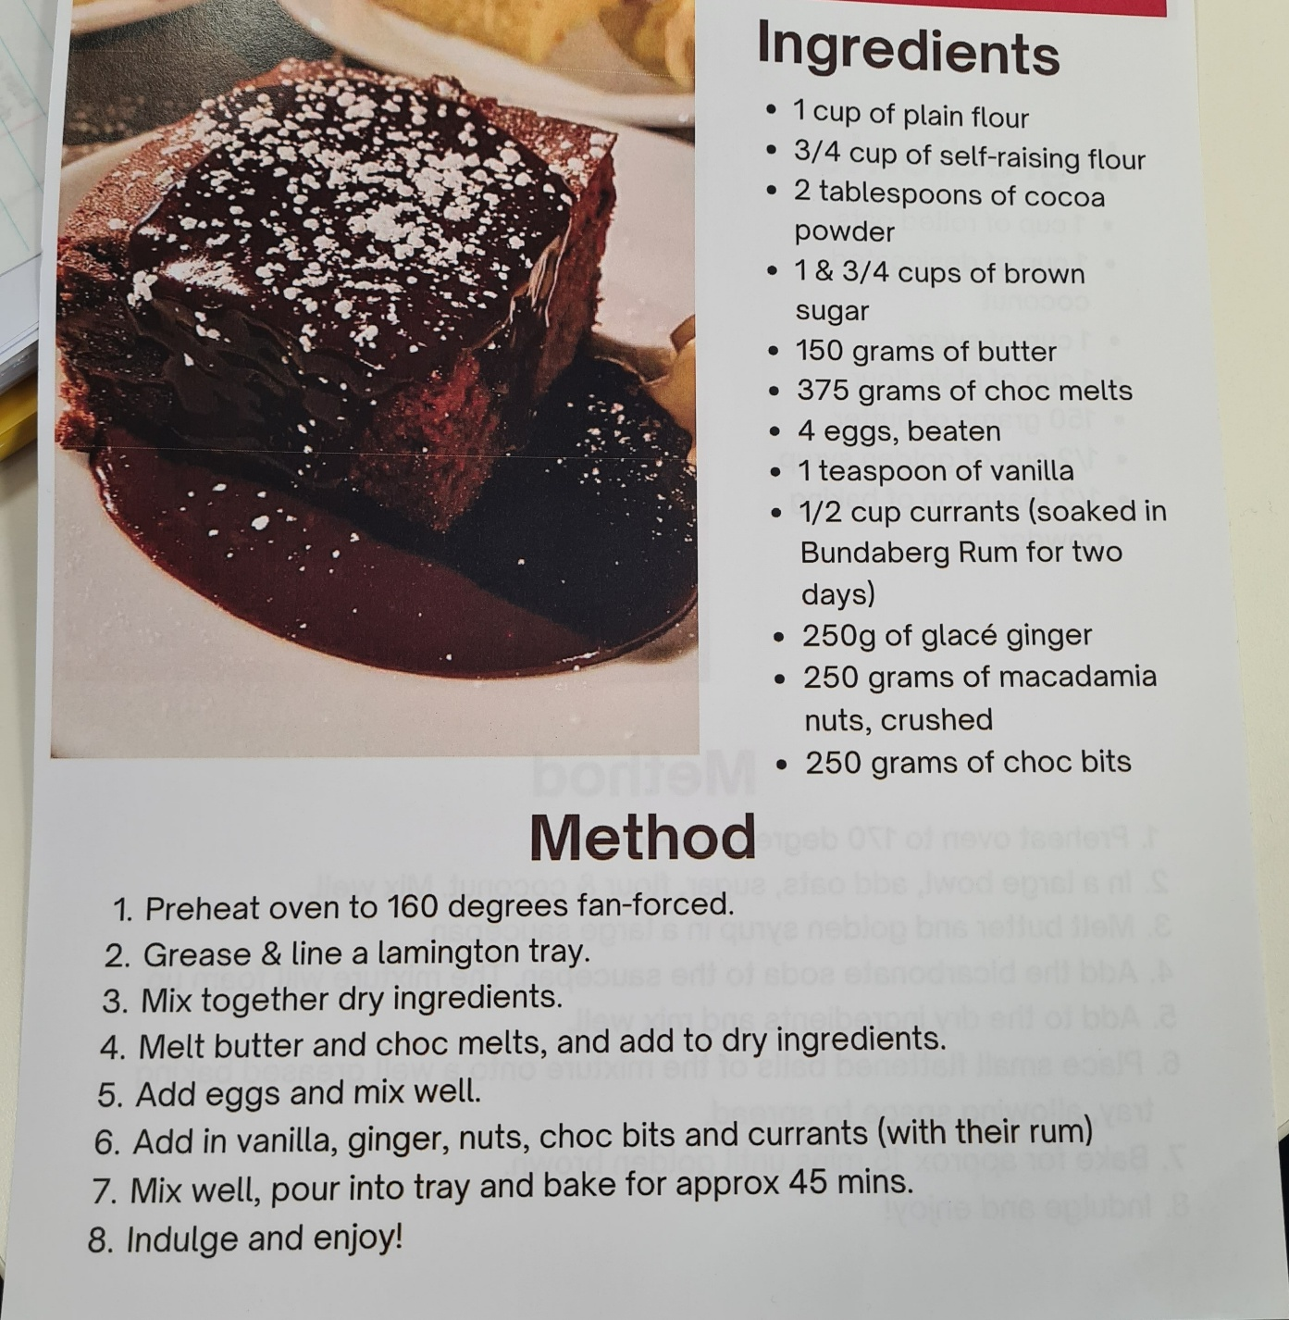

**ANNUAL BOWLS REPORT**

Harry Wheeler

**Bowls Report June 2025**

Recently the Bowls Club held a meeting to review the 2025 annual tournament

and the year’s bowling in general. Present were **Richard Fisher, Rod McClurg.**

**Mick Dowd , Ian Holwell , Helen Molloy , Joy Wheeler and Harry Wheeler.**

It was agreed that the present tournament format was again very successful

and this format should be adopted for future events.

The **2026 tournament** will be held once again on the last **Monday in March** i.e.

**Monday March 30th, 2026,** at the Ararat Bowls Club. **Rod McClurg** will notify all

clubs which have participated in the past of this date.

Joy and Helen agreed that the B.Y.O. catering should be continued as the system

was successful and all participants seemed quite happy. We will provide

morning and afternoon tea.

**Rod McClurg** will be our club liaison officer as he is familiar with all

participating clubs bowl’s organizers.

**Harry Wheeler** will contact all our regular sponsors who have contributed so

generously in the past.

Players participating in away tournaments will receive **$10** each and drivers **$60**

to help defray travel costs.

In order to comply with new banking procedures, we will open a new card

account as soon cheques will no longer available. Our present general savings

account will continue and the signatories will be **Rod McClurg , Glenys Andrew** and

**Harry Wheeler** and any two will be able to sign. A new card , account with

limited funds will be opened in the name of **Harry Wheeler**. This basic

procedure is already used by our club and the camp’s committee.

As the bowl’s club is in a sound financial position it was resolved to **donate**

**$500** to the **Ararat Probus Club**. The general committee is to decide how this donation

will be used for the benefit of all club members.

Our Bowl’s Club is now in recess until the **2025/26** resumes usually in **mid**

**October.**

**Harry Wheeler**

**Bowl’s Organizer**

*Thanks to Harry and his team for all their hard work. They manage each year to make a donation to our club and also provide great exposure for the Probus Club of Ararat !!!!*

|  |  |  |  |  |  |
| --- | --- | --- | --- | --- | --- |
| **June**  **2025** | **Committee**  **Meeting** | **General**  **Meeting** | **Chalambar**  **Coffee** | **Guest**  **Speaker** | **Morning Tea**  **Roster** |
| 5th | 10.00am |  |  |  |  |
| 12th |  | 10.00am  Followed by lunch at Chalambar G.C |  | Superintendent Sharon McCrory. A life in Policing | John and Mieke Hunt 9.30am. Instructions rear of syllabus handout |
| 19th |  |  | 10.00am |  |  |

|  |  |  |  |  |  |
| --- | --- | --- | --- | --- | --- |
| **July**  **2025** | **Committee**  **Meeting** | **General**  **Meeting** | **Chalambar**  **Coffee** | **Guest**  **Speaker** | **Morning Tea**  **Roster** |
| 3rd | 10.00am |  |  |  |  |
| 10th |  | 10.00am. Followed by lunch at the Ararat RSL |  | Visit to Gason’s Factory Ararat | Ambrose & Verna Joyce 9.30am. Instructions rear of syllabus handout |
| 17th |  |  | 10.00am |  |  |



**“This Newsletter is Private and Confidential for Probus use only and is not to be used for any other purpose”**