
PROBUS CLUB OF ARARAT
Incorporation #A0003724B.
NEWSLETTER- May 2026
ISSUE 211
P.O. Box 258, Ararat 3377 www.probusararat.com Secretary Ann 0417328631
Email: a.sullivan3@bigpond.com
Greetings Probians. Welcome to the May 2026 Newsletter. I trust the Newsletter is finding you keeping well!
Welcome to the May Presidents Report.

Hasn't it been a very busy month what with the Bowls Tournament (30th March but to be included in April), the April General Meeting at Maroona, Anzac Day service at the Cenotaph. The Bowls Tournament went off really well and the weather was lovely. 88 bowlers enjoyed themselves at Ararat Bowling Club. Many thanks to the Club for the use of the facilities for the day.

The April General Meeting was held at Maroona and was well attended . After a delicious morning tea courtesy of Irene and Kerrin Gellie, we were treated to a very interesting talk from Kerrin outlining his involvement in collecting details of local history. Not wanting to blow his own trumpet, Kerrin has had three books published on ww1 and ww2 in which local people were involved. Well done, Kerrin. The lunch that followed at the Maroona hotel was excellent. Thank you Ken for organizing the day.

Ann Sullivan and I laid a wreath on behalf of the Club at the Anzac Day service. Nice to see quite a number of Probians in attendance.

Our next General Meeting will be at Pyrenees House (Ararat Hospital) and following morning tea, a tour of the hospital. PLEASE NOTE, remember that there are TWO HOUR PARKING RESTRICTIONS in the vicinity of the hospital. THEY ARE ENFORCED. Look forward to catching up with you all on the 14th.
President Ian.

APOLOGIES
To be phoned or texted prior to the meeting to Secretary Ann on 0417328631

PROBUS CLUB OF ARARAT GENERAL MEETING 09/04/2026 10.00 a.m.
Venue: Maroona Historical Centre
Present: 50
Welcome: Ian Holwell welcomed everyone to the “great” venue.
Apologies: Marlene Poon, Neil Billett, Anne & Barry Joyce, Jan Porter, Val & Lawrie Tonkin, Chris & Norm Clark, Bertha Grant, Stan Payne, Terry Holwell, Bill & Rodney Byron, Sonia Smith, Chris McIntyre.
Moved David Haddow Seconded Mark Harrison Carried

President Ian presented Geoff Wilkinson with his Probus badge.
Visitors: Harold Thomas introduced by Ken Richie, Harry Collins - John Mawson, David Haddow – his wife, Gwen, Mark Harrison – Dot & Steve Dykes.
Birthdays/Anniversaries: Ambrose Joyce (87 years), Geoff Wallace, Terry Holwell, Lawrie Tonkin. 65th Wedding Anniversary – Chris & Norm Clark.

Minutes of the previous meeting were circulated with the Newsletter.
Moved Pam Wright Seconded Harry Collins Carried.

Correspondence
Inwards: P.S.P.L. Amplifon Rewards Hearing Month. P.S.P.L. Updated membership list – 64. C.A.V. – notification that the application to change the association rules i.e. Constitution for Probus Ararat has been accepted. P.S.P.L. Wine Offer. P.S.P.L. Management Update. Probus Club Murders – new book. P.S.P.L. Active Retirees – March. P.A.V. Minutes of March Meeting & A.G.M. P.S.P.L . Western Japan Autumn Special. P.S.P.L Virtual Information Session Dates. P.S.P.L. Silvano Martignago C.E.O. reply to Ian Holwell’s letter (on behalf Tim Andrews) re the cost to Victorian Clubs Consumer Affairs Victoria lodgement fee, the lead-up process with regard to implementation and updating of the Constitution and the Alternatives going forward. Joy Wheeler – Thank you card to the Committee of 2025 for giving her the honour of being made a Life Member.
Outwards: Application for the Pitch Festival grant ($1000.00).
Moved Pauline Weeks Seconded Ray Hurstfield Carried.

Treasurer’s Report
Opening Balance: $713.29 Income: Membership – 2355.00, Joining Fee 20.00 Stubby Holder 10.00, Wrongly Deposited Camps 210.00 Total $2595.00 = $3308.29. Expenses: Consumer Affairs (Constitution) 183.10, Consumer Affairs (annual Fee) 50.40, Postage (Constitution) 8.80, Lardners (President’s Badge engraving) 10.00, Lardners (Name Badge) 11.50, P.O. Box (annual fee) 165.00, Website (annual fee) 241.37, Refund to Camps Account 210.00 Total $880.17. Closing Cash Back & Bank Statement Balance $2428.12. Fixed Term $2692.81 Reinvested to 25 May, 2026 @ 4%. Treasurer’s Petty Cash: Opening Balance 59.97 Less A4 Photocopy paper 8.50 Closing Balance $51.47
Moved Glenys Andrew Seconded Maureen Smart Carried
Glenys Andrew reminded members that membership fees were due.

Reports
Ian Holwell read out the following Committee Roles:
Pauline Weeks – Vice President & Welfare.
Ann Sullivan – Secretary.
Glenys Andrew – Treasurer.
Maureen Smart – Assistant Secretary & History.
Ken Richie – Guest Speakers, Syllabus and Mystery Tour.
Glenda Hurstfield – Assistant Treasurer.
Allan Wall – Bowls Liaison.
Mark Harrison – Newsletter.
Tim Andrew (non-Committee) to produce the Newsletter until June.
Stan Payne - Meet & Greet.
Glenda & (Ray Hurstfield, Rod & Nancy McClurg – non-Committee members) – Camps.
Rod McClurg (non-Committee) Website.
Merilyn Payne (non-Committee) – will assist with photography as needed.

Camps: Glenda Hurstfield presented the following report:
- 42 members and their partners attended the Nagambie Camp, about a 3 hour drive from Ararat.
- Monday evening – Happy Hour & B.B.Q. tea.
- Tuesday – Michelton winery, which has Australia’s largest operating underground cellar, a stunning Aboriginal Art Gallery and the Aston Tower Lookout. Next stop – Tahbilk winery and eco wetlands. Tahbilk was established in 1860 and is Victoria’s oldest family owned winery. Happy Hour – sausage sizzle, supplied and cooked by the Caravan Park staff. 4 of the staff joined in with the Probus group. Nicole – guest speaker. She spoke about the 2024 floods and how it took over 12 months to recover.
- Wednesday – car pooled and drove to Kialla, just out of Shepparton. First stop MOVE – Museum of Vehicle Evolution. There was: the Loel Thomson costume collection, plus cars, bikes, motor bikes, trucks and buses on display. The Furphy Museum showcased the history of the family business. Lunch – Milestone Café. Dinner – traditional pizza meal & ice cream.
- Thursday – a short drive to the Goulburn Weir – hot cross buns for morning tea. Luncheon at the Rowing Club. Two-hour sunset cruise down the Goulburn River towards the heritage listed Kirwan’s Bridge, the longest timber bridge in Victoria, built in 1890.
Glenda thanked everyone who helped with food preparation at Happy Hour, with setting up and packing up, for looking out for each other and carpooling, plus a special thanks to Maz for all the photos. Well done to all.
Bowls: Rod McClurg presented the following reports:
Warrnambool Friday March 20th Three teams travelled to Warrnambool for their Annual Probus bowls at City Memorial Bowls Club (under the dome). Only one team had any success with Neil Coates, Rod McClurg, Glenda Cameron and Geoff Wallace winning 2 games and only losing the last game by one shot. Rod managed to win chocolates for the ditch to ditch and we also scored some raffle prizes. The best result of the day was getting 2 more teams to play in our tournament (from Terang and Koroit). A very enjoyable day playing at a venue with facilities not seen in our area.
Probus Club of Ararat Bowls Tournament was held on Monday March 30th 2026
Our Annual Bowls tournament was held in perfect weather conditions with 22 teams (88 players) competing. Teams travelled from Ballarat, Warrnambool, Daylesford, Nhill, Warracknabeal, Hopetoun, Maryborough, Donald, Charlton, Koroit, Terang, Dunolly, Hamilton and Ararat, a very good result considering the fuel prices and availability. Competition was fierce but friendly on the beautifully prepared greens at Ararat Bowling Club, ending up with 4 teams winning 3 games each. First place on the day went to Begonia City, followed by Warracknabeal, Warrnambool and a local team from Ararat (Neil Coates, Geoff Wallace, Geoff Wilkinson and Pam Wright) coming in fourth. Very generous sponsor support from local businesses meant many players went home with prizes from either playing or the monster raffle. Many club members helped out on the day including a team of hardworking ladies in the kitchen, raffle ticket sellers, photographers, umpire/manager and bowls committee members.
All day it was evident that the fun, fellowship and friendship of Probus was alive and well with chatter and laughter in the clubhouse and on the greens.
Hopetoun Wednesday April 8th 20.4.26 We sent 3 teams to Hopetoun for their Annual Probus bowls. This was the last event in the 25/26 season, with more kicking off in October. We are fortunate to have an excellent pool of players that were willing to travel to enjoy a game of bowls and support other clubs.
Rod said that the Camps books had been audited and that the Bowls Committee had presented $200.00 to the Club for morning tea expenses.
Harry Wheeler said that the Annual Ararat Bowls Tournament was a great success. He thanked all the non-bowlers who came along and helped. He noted that Hopetoun was very appreciative to those who came to their annual tournament. The winning team was – Neil Coates, Geoff Wallace, Rod & Bill Byron. Runners Up – Geoff Wilkinson’s team.
Joy Wheeler thanked the ladies, who worked in the kitchen at the Ararat Bowls Day.
Ian Holwell noted that a quarter of western Victoria was represented at the Ararat Bowls Tournament. Rod McClurg said that 4,800 kms. was travelled for this tournament.
Website: Rod McClurg - Plenty of photos are being added to our website with new committee, camp to Nagambie and our Annual Bowls tournament. Many thanks to everyone that helped out with taking photos (especially Maz Payne).
Welfare: Pauline Weeks reported that Anne Joyce said that Barry was “up and down”. She noted that Anne Shalders was at the meeting. Jan Porter is going “o.k.” - “up and down”. She is back on treatment. Stan Payne has been unwell with an eye issue.
Syllabus Ken Richie noted that lunch would be at the Maroona Hotel at 12.15 p.m. He thanked Kerrin and Irene Gellie for their hospitality. The May General Meeting will be at the Ararat Hospital. Members will meet at Pyrenees House. The hospital will provide morning tea. Ian Holwell said that parking would be limited at the hospital and to be aware of the 2 hour parking limit. He suggested parking past J Ward. Ken thanked Mick Dowd for printing the annual syllabus.
History: Maureen Smart has added photos of: Ian Holwell’s Annual Report, Geoff Wilkinson’s Induction, the Induction of Ian Holwell as President, Nagambie photos, including Ian Wright celebrating his 85th birthday at the Camp, Ararat Bowls Day and Glenys Andrew’s financial report until 31/12/2025.
Moved Glenda Hurstfield Seconded Nancy McClurg Carried

General Business

Ian Holwell said that the Committee had proposed that Probus’ 50th Anniversary be celebrated in September with a special morning tea. The guest speaker will be Jack Ward, the T.V. reporter.
Mark Harrison proposed that Probus members might consider forming an informal fishing group which would meet to fish the local waters. He said that members, who were interested, should see him today. Mark also thanked Tim for agreeing to produce the Newsletter until his return in June.
Ian Holwell announced that he and Ann Sullivan would represent Probus Ararat and lay the wreath at the Ararat Anzac Service. He thanked Joy Wheeler for volunteering to make the wreath.
Ian thanked Rod McClurg for bringing the speaker to Maroona.
Harry Wheeler said that the Rainbow Trip had been postponed due to the cost of fuel.
Ann Sullivan thanked Rod McClurg for his work on the Ararat Probus Website; keeping it up to date with photos.
Meeting Closed:10.45 a.m.

Well done to our Past President and Life Member Joy Wheeler who featured in the Ararat Advocates “AS I REMEMBER” circulated edition 8/5/26. It makes for a great read and promotes the members in our club and also the Ararat Probus Club. Well done Joy a great effort and a great article.

Ken Richie introduced Kerrin Gellie
Kerrin welcomed everyone on behalf of he and Irene.
He spoke about the following:
- Maroona was initially at the racecourse – 1859 – before any structures had been built.
- About 2 years later the Hopkins Inn (later known as the Crown Hotel) was built. The authorities structured the town plan around the Inn.
- Not long after this the Ararat to Portland railway line, which ran through Maroona, was established, which led to the town plan being shifted to the railway area.
- Later a Coffee Palace (burnt down) was built at Maroona, as there had to be 7 miles between hotels e.g. the Ross Bridge and Hopkins Inn Hotels.
- The current Maroona Hall was built as Prestige was looking for a footy club.
- When the Maroona Memorial was celebrated Kerrin collected pictures for this event – thus the pictorial display commenced. 60 people attended the Memorial.
- Kerrin’s Mum was a Jackson. His family was the fifth generation to attend the local school. Thus he felt that it was important to have a Maroona museum.
- 1954 – the last race meeting at Maroona. The tin shed was shifted when Prestige came down from Ararat.
Kerrin became very aware of how quickly History can be lost after the Moyston fires. This led to his writing 3 History books – Soldier Settlers around Lake Burrumbeep, 1st World War Memorial – he tracked down all those who had enlisted around Maroona, 2nd World War.
Ian Holwell thanked Kerrin for his fantastic presentation.
John Hunt presented Irene and Kerrin with a Probus Certificate of Appreciation. John noted that their morning tea for members was very much appreciated.
Secretary Ann Sullivan President Ian Holwell

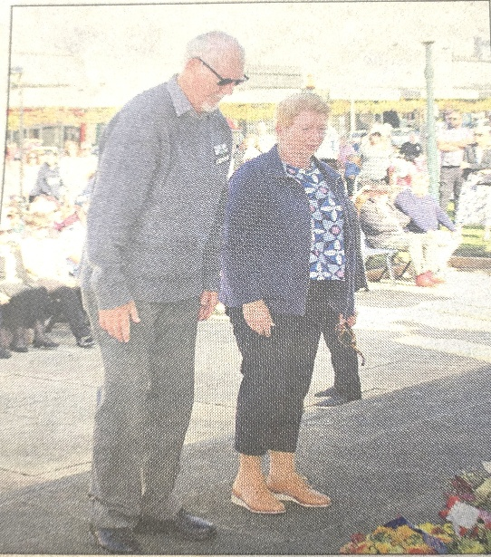
President Ian and Secretary Ann represented the Probus Club of Ararat on Anzac Day at the Wreath Laying ceremony. (Photo courtesy of the Ararat Advocate)
A big shout out to Probian Joy Wheeler who prepared the Probus Club of Ararat’s wreath for Anzac Day



Pitch Music & Arts Festival Community Grant
Dear Ann,
We would like to thank you for your recent interest and application to the Pitch Music & Arts community grant for the ARCCLGA area. We had a wide variety of applicants from the community who exhibited many worthwhile projects and initiatives. Upon review of your proposal the grant committee is pleased to notify Probus Club of Ararat Inc. of your successful outcome in Tier 1 for a grant of up to $1000.
WHAT A GREAT RESULT FOR OUR CLUB
THE 2025-2026 MANAGEMENT COMMITTEE UNAMIOUSLY ENDORSED A SUBMISSION, TO APPLY FOR A COMMUNITY GRANT OFFERED BY THE PITCH MUSIC & ARTS FESTIVAL (Music Festival held in Moyston each year on the March Labour Day weekend). AS YOU CAN SEE THE APPLICATION FOR THE GRANT WAS SUCCESSFUL FOR OUR CLUB AND IT HAS BEEN CONFIRMED AT $1000. Probians Secretary Ann Sullivan and Syllabus Co-Ordinator Ken Richie and Assistant Secretary & History Maureen Smart prepared the submission on behalf of the club. Well Done!!!!!!

FROM KEN RITCHIE :RE HOSPITAL TOUR
Please be at Pyrenees House Girdlestone Street, Ararat prior to 10.00am. Upon your entry to Pyrenees House make your way to the Mt.William room, that is where the General Meeting will take place. (There will be signage).
At the completion of the General Meeting morning tea will take place provided by the hospital catering team. After morning tea the tour will take place. Due to infection control protocols and the wellbeing of Probians, Hospital Staff and Patients any Probian who believes they have an active cold/ flu you will be required to test for covid. If negative for covid, wear a mask at all times whilst in the hospital. A positive test for Covid would require you to be an apology for the meeting and the tour.
Parking is strictly enforced by council and penalties are issued. So please make sure you are acquainted with the location and meaning of parking signs

Here is a little ditty about the “plug” that occurred on the Nagambie Camp
Probian Rod McClurg was the author and kindly provided it for the Newsletter.
Well Done you Rod!!!
🤣 🤣 🤣 🤣 🤣 🤣

ON SITE THIRTY-EIGHT AT NAGAMBIE THE BOYS WERE IN A SWEAT
SOMETHING WAS MISSING BUT NOT THE COLT FROM OLD REGRET
THE SINK PLUG IN THE NEILS CARAVAN WAS NOWHERE TO BE FOUND
NEIL MIGHT DE A DECENT BOWLER BUT HE'S NO BLOOD HOUND

IT WAS THERE THIS MORNING THEY BOTH SAW IT ON THE SINK
BUT SINCE THEN IT HAS VANISHED, GONE MISSING IN A BLINK
HOW CAN THEY WASH THE DISHES THEY WERE IN A BIND
THAT RED BUNG WAS ELUSIVE, BLOODY HARD TO FIND

THEY HAD TURNED THE VAN UPSIDE DOWN ALL TO NO AVAIL
HEAD SCRATCHING AND BLAMING OTHERS STILL LED TO A FAIL
NEIL HAD NO ANSWER TO THE PROBLEM, GEOFF NO HELP AT ALL
SO THEY BORROWED A SPARE FROM GLENDA, SHE WAS ON THE BALL

THEN IT SHOWED ITS PRESENCE, IN GEOFFS DRINK BOTTLE NO LESS
THEY BOTH WONDERED HOW IT GOT THERE CAUSING SUCH A STRESS
IT GOT STUCK TO AN ICE CUBE WHEN THE DRINK BOTTLE WAS REFILLED
THE BOYS WERENT SO MUCH HAPPY, THEY WERE BLOODY THRILLED

LAST YEAR NEIL LOST HIS PHONE WHILE AT SWAN HILL HE WAS CAMPED
NOW THIS TIME AT NAGAMBIE THE SINK PLUG HAD THEM STUMPED
WE ARE LEFT TO WONDER WHAT AT THE NEXT CAMP WILL BE MISLAID
PLENTY OF ENGTERTAINMENT FROM THE STAWELL BOYS IM AFRAID
🤣 🤣 🤣 🤣 🤣 🤣

A Basic Understanding of Detecting AI in Pictures
Artificial intelligence (AI) can now be used to create images that look like real photographs. These images are often made using computer programs that learn from millions of real pictures. While AI-generated images can be useful for art, design, and entertainment, they can also be misleading if people believe they are real. Because of this, learning how to detect AI-generated images is an important skill.
One of the most basic ways to detect AI in pictures is by closely examining the image. AI images sometimes include small mistakes that would not usually appear in real photographs. For example, people in AI images may have an incorrect number of fingers, strangely shaped hands, or uneven facial features. Hair might blend unnaturally into the background, and skin can look too smooth or “plastic-like.” Text within images, such as signs or logos, can also appear misspelt or unclear.
Another helpful method is checking the image’s details, known as metadata. Real photographs usually contain information about when and how the photo was taken, including the camera type and date. Many AI-generated images either have no metadata or show signs that image-generation software was used instead of a camera. While metadata can sometimes be edited, missing or unusual information can be a warning sign.
People also use AI detection tools to help identify whether an image is computer-generated. These programs analyse images in ways that humans cannot, such as looking at pixel patterns and digital noise. The tools then give a result showing how likely the image is to have been generated by AI. However, these tools are not always correct, so they should not be relied on alone.
Because AI images are becoming more realistic, the best approach is to use more than one method. Looking carefully at the image, checking its information, and using detection tools together gives a more accurate result. It is also important to think critically about where the image came from and whether it comes from a reliable source.
In conclusion, detecting AI-generated images requires attention, digital awareness, and critical thinking. As AI technology continues to improve, learning these skills will help the wider community make better decisions about what they see online and avoid being misled by fake or manipulated images.
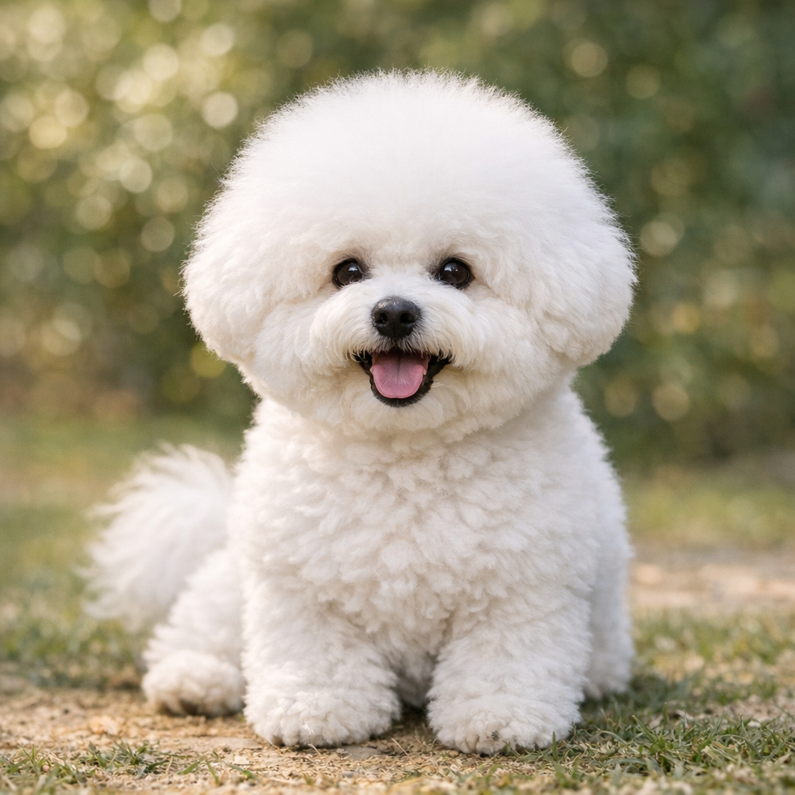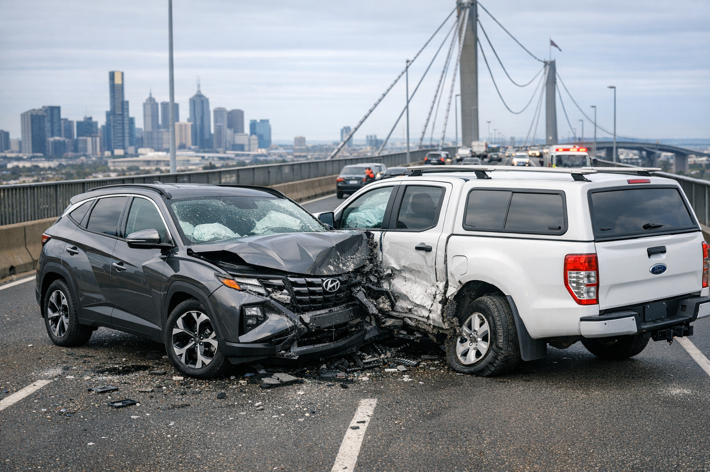
Ai car accident generated in 42 seconds. No previous photos provided.
My Ai Bichon Freise dog My Hyundai Tucson and Probian
John Hunts Ford Ranger in a collision
on the Westgate Bridge

A Basic Understanding of Detecting AI in Pictures
Acting Editor’s Note
Please remember that under the Ai umbrella there are also other forms of Ai methods
- Photos generated from scratch as on the previous page
- Voice Ai is now prominently used in fraud and scams
- Also photo shopping is now blended with Ai
The Ai photo of the Westgate Bridge vehicle accident was created in 42 seconds. I opened the Ai text box and typed in the following, Can you generate an Ai image of a 2025 Hyundai Tucson gun metal grey in colour in a collision with a Ford ranger dual cab white in colour, it has a canopy. The accident took place on the Westgate Bridge Melbourne Victoria Australia?
The fascinating aspect of the accident photo is not necessarily the two cars but what really gets me is how the Ai generated the accident damage to the cars!!!!
After the accident I got a local towing operator “Evans Park Towing” to take my damaged car to my factory at 4 Domain Circuit Ararat (Evans Park estate)
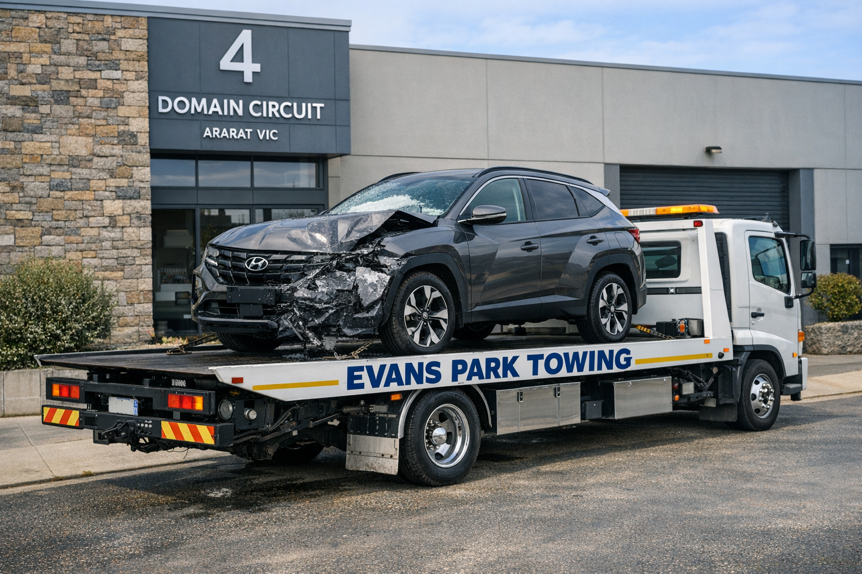
outside my home address. No further information was provided. Generated from scratch
This Ai picture was generated in 38 secs. I told Ai to use my accident car put it on a tow truck run by Evans Park Towing and park it
I then got the panel beater to identify the key components to complete the repair. To make it cheaper he had a 2nd hand white rear panel, that he said he would spray in my colour. I was very lucky, the towie found my number plate on the bridge and put it back on the car for me

This Ai picture was generated in 47 secs. It apologised for being slow. The info I provided was to take my accident car from the tow truck and
then provide the panels/parts that would be needed to repair the damage to my car. I also told it to insert my Vic rego plate.
Be very careful about pictures, videos, company promotional material and any bank and/or government material. “GET THE PICTURE”

May  2026 | Committee  Meeting | General  Meeting | Chalambar  Coffee | Guest  Speaker | Morning Tea  Roster
7th | 10.00am
14th |  | 10.00am Meet at Pyrenees House (Ararat Hosp) Girdlestone St for General Meeting, then Morning Tea and a tour of Ararat Hospital followed by lunch at the RSL |  | Tour of the Ararat Hospital | Ken Richie & Tim Andrew. Start 9.30am Instructions on rear of syllabus
21st |  |  | 10.00am

Jun  2026 | Committee  Meeting | General  Meeting | Chalambar  Coffee | Guest  Speaker | Morning Tea  Roster
4th | 10.00am
11th |  | 10.00am  Lunch afterwards at Sicillians |  | Dianne RADFORD OAM Blue Ribbon Foundation (Ararat Branch) | Margaret Carmichael & Helen Molloy. Instructions on rear of syllabus
18th |  |  | 10.00am
YES, ITS THAT TIME OF THE YEAR AGAIN PROBIANS MEMBERSHIP FEES ARE DUE $60 per member. PAYABLE BY MARCH 23,2026
Payment by the following,
Online EFT via Bendigo Bank transfer to Probus Club of Ararat using
BSB 633000 Account Number 144517661 please put your name as the reference in order for us to process your payment.
OR
Pay directly to Bendigo Bank Barkly Street using the above BSB and ACCOUNT numbers. Please advise the teller at time of processing, that your name is required as the reference in order for us to process your payment

