
PROBUS CLUB OF ARARAT
Incorporation #A0003724B.
NEWSLETTER- Dec 2025
ISSUE 207
P.O. Box 258, Ararat 3377 www.probusararat.com Secretary Ann 0417328631
Email: a.sullivan3@bigpond.com
Greetings Probians. Welcome to the December Newsletter. I trust the Newsletter is finding you keeping well!
PRESIDENT Ian’s REPORT December 2025
Hello fellow Probians.
Welcome to Summer - well sort of. It will come eventually and then we will be wishing winter would return. Our 'Mystery Trip" to Melbourne was a great success, thanks to the great organizing by Ken. Many thanks on behalf of all who went.
It is not long to the Christmas Dinner. On behalf of Terry and myself, I wish everybody a very happy Christmas and a safe and enjoyable break into the new year.
With the new year fast coming, please consider putting your name into the hat for positions on the committee. More about this early next year.
Just a few thanks to Committee Members and General Members who have made my position as President so much easier.
Joy, for her advice and support in helping me take up this very important position in the Club
Our Secretary, Ann who has been a great help with her wise council and experience.
Glenys for keeping the Club on the straight and narrow financially.
Maureen for keeping a great record of events involving the Club.
Tim for producing a fantastic newsletter plus the survey, camp competition and putting in hundreds of hours on the Club Constitution.
Rod and Harry for organizing the Bowls Teams etc.
Ken for supplying our guest speakers and mystery tour venue.
Rod, Nancy, Glenda and Ray for researching and organizing our Annual Camp.
Pauline for looking after the Welfare Portfolio and keeping us informed of all on the sick list.
Ambrose and Brian who wash up after our meetings.
Anne Joyce who produces the wonderful calligraphy for or Certificates.
Plus, all who have made my position as President an enjoyable experience this year. I appreciate your support.
I look forward to the December meeting as I know you all do when we will be entertained by Ararat West P.S. Choir singing Christmas Carols. I hope you have warmed up your vocal cords. Look forward to seeing you all at the meeting
President Ian

APOLOGIES
To be phoned or texted prior to the meeting to Secretary Ann on 0417328631

YOUR ACTIVE RETIREES LINK FOR THE DECEMBER DIGITAL EDITION IS BELOW
https://issuu.com/monikap-probussouthpacific/docs/active_retirees_magazine_-_december_2025_issue

Ararat Probus General Meeting Minutes 13/11/’25
Present: 48
Welcome: President Ian Holwell welcomed members to the meeting on this fine, sunny day.
Apologies: Jan Porter, Richard Fisher, Gerry Hirst, Neil Coates, Geoff Wallace, Rod & Bill Byron, Rod McClurg, Neil Billet, Stan Payne, Allan Wall, Lawrie & Val Tonkin, Sonia Smith, Norm Clark.
Moved Pauline Weeks Seconded Nancy McClurg Carried
Birthdays: Alan Grant, Rod Smart, Barry Joyce, Ann Sullivan.
Induction: President Ian inducted Pam Wright into the club. Ian noted that it was nice to have Pam join the club with her husband, Ian.
Visitors: Mark Harrison introduced Elizabeth Anderson, who is visiting from England. Carmel Beer and Theresa Reid were attending their second meeting.
Lunch numbers 21
Moved Anne Joyce Seconded Joy Wheeler Carried
Minutes of the last meeting were circulated with the newsletter.
Moved Chris Clark Seconded Terry Holwell Carried
Correspondence
October
Inwards: Probus South Pacific – Happy Probus month. Probus South Pacific – National Travel. Probus South Pacific – On Course Tours. Niagara Therapy. Probus South Pacific Management Committee Update. Probus South Pacific – Active Retirees Digital Magazine. Probus South Pacific – Wendy Wu Flight Tours Sale. Probus South Pacific – Updated membership list – 64 members. Probus South Pacific – Limited Edition Wine Special – Chandon. Probus South Pacific – Congratulations for Probus Month Activities; Reminder re succession planning. Probus South Pacific – Management Committee Update. Probus South Pacific – Levande Retirement Living Information Session.
Moved Maureen Smart Seconded Glenda Hurstfield Carried

Treasurer’s Report
Balance B/Fwd. $1336.16 Income Mystery Tour $1310.00 Total $2646.16
Expenditure Ararat Uniting Church hall $529.20 Christmas Decorations & Serviettes $90.80 Total $620.00
Bank Statement & Cash Book Balance $2026.16
Fixed Term Opening Balance $3130.88 Interest 3.9% Reinvested to 25/11/2025
Treasurer’s Petty Cash Opening Balance $57.37 Less Christmas Decorations $45.00 A4 copy paper $9.50 Stationery $5.00 Total $59.50 Closing Balance $2.13
Moved Glenys Andrew Seconded Anne Shalders Carried

Reports
Publicity: Ian Holwell said that he had submitted the Possum Cameron article to “The Advocate”.
Camps: Glenda Hurstfield presented David Haddow with his consolation prize for the Camps Competition. Glenda said that she and Ray would be going to Nagambie to research activities. 40 have booked for the 2026 Nagambie camp.
Bowls: Harry Wheeler said that the Ararat Probus team had gone to the Nhill tournament today. Tournaments scheduled for 2026: March – Warrnambool, April – Ararat.
Website: Ian Holwell said that Rod McClurg had noted that website visits were up 31%. Rod asked that if anyone noticed any errors on the website could they please contact him.
Welfare: Pauline Weeks said that people whom she had contacted were at the meeting. Lawrie Tonkin has been unwell.
Christmas Lunch: Pauline Weeks noted that the cost for Christmas Lunch was $30.00 per head. Those attending do not have to pay until the day of the lunch. Pauline said that if people put their name on the list on the table and did not attend the lunch, they would still need to pay their $30.00. Pauline was also hopeful of getting the children from Ararat West Primary School to sing at the Christmas General Meeting.
History: Maureen Smart said that she had added the following photos: “The Advocate” photo of the bowlers attached to Ian Holwell’s article, Harry Wheeler handing Ian Holwell the $500.00 donation from the Bowling Club (retrospective from May), Glenda Hurstfield presenting Joy Wheeler with first prize for the Camps Competition, Glenda handing Terry Holwell and John Hunt their consolation prizes, Possum Cameron and his daughter, Sally, Ian Holwell and Rod McClurg laying the wreath from Ararat Probus on Remembrance Day.
Syllabus: Ken Richie said that the speakers for today were “home grown” – Joy & Hary Wheeler. He noted that there would be no speaker at the December General Meeting due to the Christmas lunch.
Mystery Tour 20th November – Ken noted that coaches would be replacing trains to Bacchus Marsh. Probus Ararat had a group booking for the bus departing Ararat at 7.01 a.m. Arrival – Bacchus Marsh – 8.49 a.m. for the 9.00 a.m. train (seats reserved for the Probus group) to Southern Cross. Ken said that he would have handouts for members at the Ararat station. 10.30 a.m. – visit to the Police Museum, 12.00 p.m. – lunch at the Royal Melbourne Hotel, 1.30 p.m. – the Aquarium. 4.17 p.m. Ararat train departure from Southern Cross, 4.55 p.m. Bacchus Marsh, 7.29 p.m. Ararat arrival. Ken noted that the club had paid for the train tickets.
Ian Holwell asked members if they would still be interested in coffee at Challambar at 10.00 a.m. on the 20th November & the 18th December. Numbers indicated that Ann Sullivan will book this venue for coffee on these dates. It was also noted that Sicilians would replace the Ararat Hotel as a lunch venue in 2026.
Ian Holwell thanked the Management Committee for their support in their various roles in 2025.
Meeting Closed: 10.35 a.m.

Speakers, Harry & Joy Wheeler – 17th November 2024 – Flight to Antarctica.
Joy spoke about the following:
- Breakfast in the Business Lounge.
- Their seating arrangement of front seat cubicles on the plane with an excellent viewing window.
- The lavish breakfast and dinner menus.
- 17th November was a very clear day.
- 17 flight paths to choose from. The flight path was chosen at Tasmania after contact with B.O.M. weather.
- The onboard information from 2 experienced Antarctic experts.
- During “down” time there were movies or documentaries to watch.
- 220 passengers on board.
- The plane carried 83 tonnes fuel and used 69 tonnes.
- The passengers were able to listen to the Casey crew on the way.
Harry presented the following facts:
- Antarctica is the fifth largest continent, and the coldest, windiest, driest place in the world.
- The ice is 4.8 kms. thick and contains 90% of the world’s fresh water.
- Chile, New Zealand and Argentina are its closest neighbours.
- Birds are mainly migratory.
- There are 16 species of penguins
- Virtually nothing grows in Antarctica.
- The flight path was 615 metres above the highest land.
- They flew over Antarctica for 4 hours.
A slideshow of photos of the Antarctic scenery was shown, highlighting glacial flows, the rugged frozen terrain and the extent of the ice.
Pauline Weeks thanked Harry and Joy for their very interesting talk and presented them with a Certificate of Appreciation from Ararat Probus.
President Ian Holwell Secretary Ann Sullivan

DON’T FORGET THE CHRISTMAS LUNCH BREAK UP, ON THE 11TH OF DECEMBER AT THE ARARAT RSL @ 12 NOON. PAULINE IS TAKING LATE BOOKINGS UP TO 12 MIDDAY FRIDAY 5TH DECEMBER (NO LATE EXCEPTIONS AFTER THAT) AS THE NUMBERS HAVE TO BE IN TO THE RSL.
A TWO COURSE CHRISTMAS LUNCH FOR $30 PER HEAD. PAYMENT UPON ARRIVAL STRICTLY CASH. CONTACT PAULINE BY MOBILE OR TEXT ON 0410 524 878 OR EMAIL TO paulineweeks@hotmail.com

ROLE OF THE MANAGEMENT COMMITTEE
The following role descriptions are taken from the Probus Club Handbook. A more detailed description of Management Committee Roles is also in the Handbook, available from Ian Holwell or Ann Sullivan.
“The Management Committee’s overall responsibility is to provide opportunities for fun, friendship and fellowship through a wide range of activities that engages its membership.
ROLES AND RESPONSIBILITIES
President
The main role of the President is to provide leadership and direction to the Management Committee to ensure the Club embodies the true spirit of Probus – fun, friendship and fellowship.
Vice President
The main role of the Vice President is to assist the President in providing leadership and direction to the Management Committee to ensure the Club embodies the true spirit of Probus fun, friendship and fellowship.
Secretary
The main role of the Secretary is to support the President to ensure the Management Committee functions smoothly. The Secretary is responsible for ensuring meetings are effectively organised and minuted. The Secretary is required to maintain up to date records and be the key point of contact for the Club.
Treasurer
The main role of the Treasurer is to see that clear and accurate financial records are maintained and that all funds are accounted for.
Publicity Officer
The role of the publicity Officer is to raise Probus awareness by generating publicity in the local community. This includes informing the local media of Club events.
Welfare Officer
The role of the Welfare Officer is to keep in touch with sick or bereaved members or those members feeling isolated and lonely or who may be in need of moral support or physical help.”
Probus Ararat
Currently some Management Committee roles are “shared” roles e.g. Outings, Activities and Tours Officer is incorporated into the Camps Committee, Syllabus and Bowls. These activities are organised by various Committee members. Website Officer, which is part of Publicity, has been adopted by a Committee Member, as too has History Officer. The role of Newsletter Officer is reflected in the production of the Ararat Probus Newsletter. Ararat Probus currently has an Assistant Secretary.
Ararat Probus has enabled flexibility within the Committee for Committee members to adopt roles that cater for their individual interests and skills. There is always the capacity within the Management Committee for members to “fill in” in other members’ absence. Overall support and assistance are high priorities.



BENEFITS OF VOLUNTEERING AS A COMMITTEE MEMBER
- Being a part of the decision-making process – personally satisfying. Offering your ideas and discussing with others gives you ownership of decisions.
- Building Networks – Joining a committee helps build stronger relationships with other club members. You’ll get to know more people and your sense of being part of the club will grow.
- Building your knowledge of the Club and Probus – You’ll learn something more about the Club and Probus from every meeting.
- Hearing other perspectives – Probus Club Members have diverse opinions on the issues which confront the club. It is interesting and instructive to hear and relate to a wide range of views.
- Giving to the Club - It will also provide an opportunity to give to the Club by making a difference in committee involvement.
At the Probus Ararat December General Meeting –
Nomination forms for the 2026 Management Committee will be available.
BOWLS REPORT
Our two teams that travelled to Nhill on November 13th had mixed results. The team of Neil Billett, Stan Payne, Allan Walls and Geoff Wilkinson were 3 game winners and scored third place on the day, an excellent result. The second team of Rod McClurg, Rod Byron, Bill Byron and Geof Wallace had 2 wins and a loss. There were 14 teams playing coming from Warracknabeal, Donald, Narracoorte, Hopetoun, Nhill, Ararat and Charlton
We had some raffle wins and enjoyed the wonderful hospitality and food that Ivan puts on at Nhill.
Upcoming dates for Probus Bowls in 2026 are Warrnambool on March 20th, Ararat on March 30th and Nhill in mid-April.
Cheers Rod McClurg

CAMPS REPORT
Our 2026 camp to Nagambie is proving popular with more than 40 booked in so far. Venues and attractions are being checked out with further visits being made by committee members. The town of Nagambie may not be large, but it is certainly picturesque with the lake being the centre piece. Our camp will take advantage of this feature and others nearby.
Cheers your Camps Committee



A woman told her friend, “I feel like my body has gotten totally out of shape, so I got my doctor’s permission to join a fitness club.”
She said, “So, I decided to take an aerobics class for seniors. I bent, twisted, gyrated, jumped up and down, and perspired for an hour. But by the time I got my leotards on, the class was already over.”
🤣 🤣 🤣 🤣 🤣
You know you’re getting old when you can’t walk past a bathroom without thinking, “I may as well pee while I’m here…
🤣 🤣 🤣 🤣 🤣

Fleigelman, who knew no English, opened a bank account and signed with two X’s as was the custom. A few years later, having done very well for himself, he came once again to the bank with a big deposit.
“Mr. Fleigelman,” asked the teller, “Why do you now use three Xs?”
Fleigelman got red in the face. “Not me, it’s my wife. You know women, always with the fancy-shmancy” he said. “Now that we got a few dollars, she thinks I should take on a middle name.”

ON THE SPOT
with
Probian Harry Collins
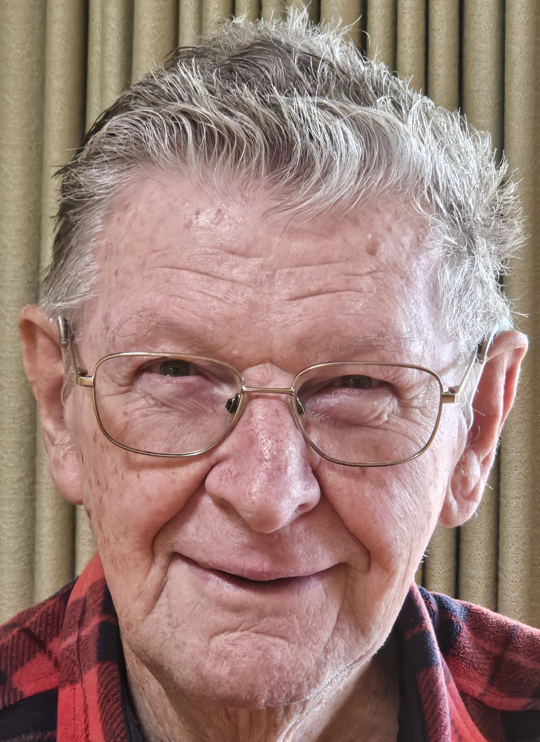`
How long have you been a member of Ararat Probus Harry?
12 years
What attracted you to joining the Probus Club of Ararat?
Meeting new friends, I’m glad I met Barry Joyce he was the Probus member who invited me
Your favourite famous person or celebrity you would have to dinner?
Nelson Mandella, given his life challenges
What would be the main course on the menu?
Steak and eggs
Do you have a favourite football code and what team?
Aussie Rules and I’m a mad Collingwood fan
Your primary occupation before retirement?
Jack of all trades, before I retired
Do you have a sport or hobby at the moment?
I’m very interested in Social Justice
First car you owned.?
A 1969 Ford Sedan, it was a bomb, I might add
Significant others?
Anna my wife of 53 years, 54 years in Jan 2026, 2 daughters and 2 grand children
How long have you lived in Ararat?
13 years this month. After 38 years in Cohuna. Our girls moved to Ballarat, and we wanted to be closer to them and the grandchildren.
Favourite movie?
Dirty Dozen, Oklahoma, My Fair Lady and the Magnificent 7 to name a few
Favourite music genre?
Rock and Roll
What irks you?
People who assume without knowing the facts
If you were president of the world for a day. What would you fix?
Sack Trump
Where did you go to school?
Primary school at St Francis Xavier in Greensborough and High school at Marist Brothers Preston
Your favourite place to which you have travelled?
Malta

Dec  2025 | Committee  Meeting | General  Meeting | Chalambar  Coffee | Guest  Speaker | Morning Tea  Roster
4th | 10.00am
11th |  | 10.00am. Followed by Christmas lunch at Ararat RSL |  | No guest Speaker due to Christmas Lunch | Mark Harrison & Harry Collins  9.30am. Instructions rear of syllabus handout
18th |  |  | 10.00am

Jan  2026 | Committee  Meeting | General  Meeting | Chalambar  Coffee | Guest  Speaker | Morning Tea  Roster
 | Christmas Break
8th |  | Picnic in the Park.  8th Jan 2026 @12 noon. BYO Food, Drink & Chair. The footy oval end of the gardens |  | N/A | Christmas Break

To all my fellow Probians may I take a minute to thank you all for your support during 2025. It’s been a great year for our Probus Club, and I believe our club is going from strength to strength. All the very best to you all and your families for Christmas and most importantly enjoy good health.
The January 2026 Newsletter will be a “General Meeting Minutes” only Edition. Your editor is taking a break in January. No one else will be around, the Subs will be at the pub watching the cricket, the copy boys will be at the cricket and the girls at the beach improving their tan
Cheers
Tim
Newsletter Editor


