
PROBUS CLUB OF ARARAT
Incorporation #A0003724B.
NEWSLETTER- July 2026
ISSUE 213
P.O. Box 258, Ararat 3377 www.probusararat.com Secretary Ann 0417328631
Email: a.sullivan3@bigpond.com
Greetings Probians. Welcome to the July 2026 Newsletter. I trust the Newsletter is finding you keeping well!
Welcome to the July 2026 Presidents Report.
Hello Probians,
Isn't it great that the winter solace has passed and the days are getting longer, even if it is only a minute a day. It won't be long that we will be complaining that the weather is too hot and daylight savings is causing our curtains to fade with the extra hour of daylight. Ha! Ha!

Welcome to our new newsletter editor, Mark Harrison. We look forward to you stamping your own style onto our Newsletter.

What a dynamic speaker we had at our June meeting. Dianne Radford OAM delivered a great talk on her life as (her words) "a working-class girl, born and bred". Dianne is the face of the Blue Ribbon Foundation which raises funds for the Ararat Hospital. The Foundation’s latest project is a Mammogram machine of which $250,000 is required. Dianne hopes the funds will be raised by the end of 2027. Other projects include "Blokes in the Bush" raising awareness of men's prostate cancer, her involvement in Legacy, the Laurel Club, and "the Ride to Remember remembering Police who have been killed in the line of duty.” All in all, it was an inspiring talk. Dianne was thanked by Probian, Mark Harrison, who presented her with a certificate of appreciation and who said she was an inspiration to us all.

Our July meeting will have Tom and Sarah Guthrie from Grampians Estate Winery as our guest speakers.

Look forward to seeing you there.
President Ian Holwell

APOLOGIES
To be phoned or texted prior to the meeting to Secretary Ann on 0417328631

Probus Club of Ararat General Meeting 11-06-2026
Meeting Commenced: 10.00 a.m.
Present: 50
Welcome: President Ian Holwell welcomed everyone to the meeting.
Visitors: The following visitors were introduced by members: Brendan Holland by Harry Wheeler, John Mawson by Harry Collins, Harold Thomas by Ken Richie.
Apologies: Richard Fisher, Mick & Rose Dowd, Pauline Weeks, Rodney Byron, Neil Billet, Marlene Poon, Carmel Beer.
Moved Norm Clark Seconded Ray Hurstfield Carried
Members stood for a minute’s silence whilst Ambrose Joyce placed Allan Grant’s badge on the Honour Board.
Birthdays/Anniversaries: Jeanette Hawley, Anne Shalders, Anne & Barry Joyce – Wedding Anniversary – 63 years.
Lunch: 24
Minutes of the Previous meeting were circulated with the Newsletter.
Moved Harry Wheeler Seconded Bertha Grant Carried
Correspondence
Inwards: P.SP.L. Management Committee Update. P.SP.L. Cruise specials. Designer Tours – promotion. P.S.P.L. Active Retirees. P.A.V. Activities High Tea at Chirnside Park Country Club on Friday July 30th at a cost of $40, Afternoon Tea Dance at the new Stonnington Sports Centre, Malvern East on Wednesday, September 23rd, with Special Guest Heather Ewart, Golf Day at Goonawarra Golf Club, Sunbury, on Thursday, November 12th cost $50.00. Allison Tyra - The View from the Hill: Women Who Made Their Mark After 40. P.SP.L. Next Sense – free virtual cochlear implant session, 18th June 1.30 – 2.30 p.m. P.SP.L. June Active Retirees Digital Magazine.
Outwards: Nil.
Moved Maureen Smart Seconded Mark Harrison Carried
Treasurer’s Report
Opening Balance: $1640.12. Income: 200.00, Membership 365.00, Pitch Music Festival Donation 1000.00 = $1565.00 = $3205.00. Expenses: Harvey Norman Sound System 1000.00, Refund of Membership – double payment 60.00, Ararat West Uniting Church rent payment 291.00 = 1351.00 Cash Book & Bank Statement Balance $1854.12. Fixed Term: Opening Balance $2692.81Plus Interest $53.74, Balance $2746.55. Reinvested to 25 Nov. ’26 Interest Rate 4.9%. Treasurer’s Petty Cash Opening Balance $41.27 less postage 10.20. Closing Balance $31.07.
Moved Glenys Andrew Seconded Joy Wheeler Carried
Reports
Publicity: Ian Holwell has submitted a few articles to “The Advocate”, which are pending publication e.g. an article and photo re The Pitch Festival grant.
Website: Nil
Bowls: In recess.
Camps: In recess. Glenda Hurstfield noted that the next camp would not entail cabins on stilts.
Welfare: Stan Payne said that the following members were doing well: Jan Porter, Anne Shalders, Marg Carmichael. He noted that it was good to see Rhonda Wall at the meeting. Barry Joyce is managing well. A condolence card has been sent to Rod & Nancy McClurg as Rod’s brother passed away.
Syllabus: Ken Richie noted that today’s speaker was Di Radford. The July speakers will be Tom & Sarah Guthrie from the Grampians Estate. He said that he was organising an August outing to “Tipping Point”, which is filmed in the Dockland studios.
History: Maureen Smart has included the following photos in the History book: the May Hospital outing, and Nick Bush & Jo Summers. Maureen noted that there was an article and photo in the P.A.V. magazine re Joy Wheeler’s Life Membership.
Moved Anne Joyce Seconded Chris Clark Carried
General Business
Ian Holwell said that Allan Wall had presented a Risk Management Policy to the Committee, which will be discussed at the next Committee Meeting. This Risk Management Policy is in accordance with the Club’s Standing Resolution 23 – “The Club will adopt a Risk Management Policy”. This policy will be outlined to members post Management Committee discussion.
President Ian thanked a number of members for their special contributions to the Club:
- Tim Andrew for his continual work on a very enjoyable Newsletter. The June Newsletter was Tim’s final edition.
- Nancy McClurg for making the cover for the new P.A. system.
- Anne Joyce for her calligraphy on the Club’s certificates.
- To those members who assist in setting up the Hall for meetings.
- To those members who assist with washing up the dishes after morning tea.
- The sub committee for the Pitch Festival grant application.
Ian said that he and Ann Sullivan were unable to represent the Club on the 8th July at the Ararat Rotary Exchange Dinner. He would be asking the Management Committee for a representative.
Ian noted that the lectern box had been gifted by the Stawell Men’s Probus Club.
Ian reminded members of coffee at Chalambar on the following Thursday – 18th June – at 10.00 a.m.
Meeting Closed: 10.22 a.m.

Ken Richie introduced Di Radford, President of the Ararat Blue Ribbon Foundation. Ken noted that Di had received an O.A.M. in 2018. Di distributed a handout to members outlining the History of the Ararat Blue Ribbon Foundation and the work that they have done since 2002 in raising money for major equipment at the Ararat Hospital. She included photos of herself – childhood to adulthood – “Working Class Girl – Born & Bred.”
In her talk she highlighted the following:
- Born in Stawell – one of 4 girls. Her father was a war veteran – a hard worker and a hard task master. Di said that she was a stubborn child and often challenged her father. She acknowledged that her parents taught her well.
- The generosity of the community.
- The latest project – a Mammography Machine - $250,000.00 required. She said that too many people from the district have to travel to Ballarat for screening. She spoke of donations from – the Ride to Remember, the Gala Night, the Ararat Lions Club and the Ararat C.B.A. branch. There are plans for a Country Lunch at Willaura. She has enlisted Tom Hawkins to attend this lunch. She hopes that the Mammography Machine project will be completed by the 2027 Gala Night.
- The “Blokes in the Bush” (partnership with the Blue Ribbon Foundation) night which 80 men attended. This night was centred on raising awareness of prostrate cancer and men’s health. David Parkin was a guest speaker.
- Another side of Blue Ribbon is Father Martin, the police chaplain, who is doing amazing support work with the police.
- She wants the Ararat Hospital to remain autonomous.
- Legacy that is 100 years old in 2029 and the Laurel Club that has just had their 60th anniversary. She noted their work for veterans’ families, especially widows.
- The volunteer work done in the community by volunteers e.g. the Community Van that feeds 50 people at a time and also the Horsham drive for sleeping bags and tents for rough sleepers.
Di’s final words were that “what you get out (of life) is what you give.”
Mark Harrison presented Di with a Probus Certificate of Appreciation noting that she was amazing to listen to and an inspiration; that she thoroughly deserved her O.A.M. He said that one of the things that attracted him to Ararat was the Hospital.
Secretary Ann Sullivan President Ian Holwell.

Invitation to the 2026 East Grampians Health Service Research Showcase [3 September 2026]
You are warmly invited to attend the East Grampians Health Service Annual Research Showcase. This year we will be launching the Modified Sport for Older Adults in Rural Communities Toolkit.
Date: Thursday, 3rdof September 2026
Time: 2:00pm – 3:00pm
Venue: Mt William Room (Pyrenees House) – Launch of Modified Sport for Older Adults in Rural Communities Toolkit. Phone (03)53529467 – to register.
If you would like to attend, you can register by phoning the number above or just come along on the day.
Jaclyn Bishop
Director, Development & Improvement, East Grampians Health Service
🤣 🤣 🤣 🤣 🤣 🤣
One of the great things about reading Tim’s newsletters was the funnies page. So I thought I’d continue the tradition. Here’s a couple of oldies but goodies for you.
Mark
An older man, living alone, decided he wanted to add a pet companion to his life. After thinking long and hard about the decision, he buys a parrot and brings it home. However, the parrot almost immediately starts insulting the older man and gets really rude. In a moment of frustration, the man picks up the parrot and tosses it into the freezer to teach it a lesson. But when the bird stops squawking, the man panics and opens the freezer. The parrot walks out, looks up at the man, and says, “I apologize for offending you, and I humbly ask your forgiveness.” The man replies, “Well, thank you. I forgive you, and I’m sorry too.” The parrot then says, “If you don’t mind my asking… what’d the chicken do?”

Two older gentlemen, Fred and Sam, went to see a movie. Merely minutes into the movie, Sam heard Fred rustling around. It appeared that he was reaching under all of the seats. “What on earth are you doing, Fred?” asked Sam. Fred indignantly responded, “I had a caramel in my mouth and it dropped out. I’m trying to find it!” Annoyed, Sam told him not to worry about it — they could get him another caramel later since that one was ruined by now. “But I’ve got to,” said Fred, exasperated. “My teeth are in it!”
Thanks to ScaryMommy website for these ones. Plenty more where they came from: https://www.scarymommy.com/jokes-seniors.

🤣 🤣 🤣 🤣 🤣 🤣
ON THE SPOT
With Probian
Pauline Weeks
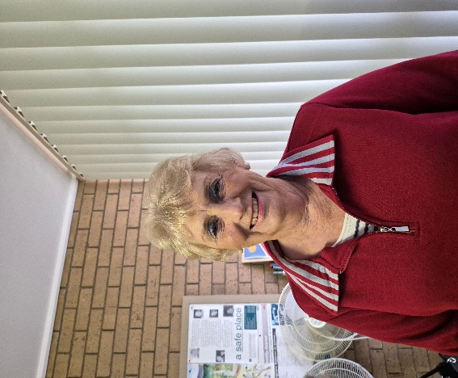
How long have you been a member of Ararat Probus and how long have you been on the committee?
Terry and I joined in about 2015 and I’ve been on the committee for 5 or 6 years

What attracted you to joining the Club?
Joy and Harry Wheeler asked us to join. I didn’t know a lot about Probus then, except that it was a good social group.

Your favourite famous person or celebrity you would have to dinner?
Celine Dion

What would be the main course on the menu?
Something very Aussie: roast lamb plus pavlova probably.

Do you have a favourite football code and what team?
AFL, Hawthorn

Your primary occupation before retirement?
I was a Hairdresser : I left school after the Leaving, worked on Dad’s farm for a year (which I loved) and then when I was 16 started hairdressing. I’ve been one ever since, and taught it for a while at the Academy in Melbourne. I still do an occasional cut for friends.

Do you have a sport or hobby at the moment?
I’m part of the bike ladies group each Monday; I swim most mornings at the indoor pool; I love reading and sewing and I really like gardening nowadays.

First car you owned.?
Ford consul 1950s model. Dad bought it for me and then it went to my brother after me.

Significant others?
Terry and I had two girls and they both have 2 children, so I have 4 grandchildren. Kirsty is nursing in Ballarat, and Shannon is on the Gold Coast. I visit her and the grandchildren there every year.

How long have you lived in Ararat?
Terry and I lived in Melbourne when we were married and came to Ararat in 1992. Terry was the officer in charge of the Ararat police.

Favourite movie?
The English Patient

Favourite music genre?
Pop: happy music

What irks you?
People who don’t clean up after their animals

If you were president of the world for a day, what would you fix?
I would try to make a fairer world and a fairer system to help people with the cost of living, to enable them to eat properly and to look after the homeless.

Where did you go to school?
St Marys primary in Cohuna and St Mary’s boarding school in Bendigo.

Your favourite place you have travelled to?
London and Paris. Having just been to Bali, that is my least favourite.
Making the switch: Are EVs right for you?
Electric vehicles have moved well beyond being a niche choice for technology enthusiasts. Today, they are becoming an increasingly practical option for downsizers looking to simplify their lifestyle, reduce running costs and enjoy a quieter, more comfortable driving experience.
For those transitioning from a larger family vehicle to something more manageable, an electric car can tick a surprising number of boxes. Modern EVs are typically easier to drive, require less maintenance and offer a smooth, effortless ride that makes everyday errands and road trips alike more enjoyable.
One of the biggest advantages is the reduction in servicing costs. Unlike petrol or diesel vehicles, electric cars have far fewer moving parts. There are no oil changes, spark plugs, timing belts or exhaust systems to maintain. While tyres and brakes still require attention, many owners find their annual servicing bills are significantly lower than those of conventional vehicles.

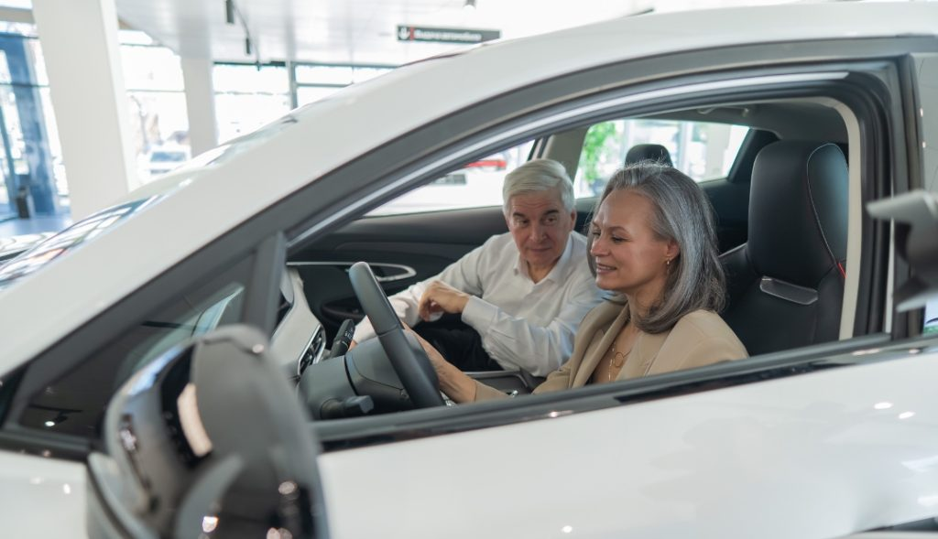
Fuel savings can also be substantial. Charging at home is often considerably cheaper than filling a tank with petrol, particularly if you take advantage of off-peak electricity rates or have solar panels installed. For those who no longer commute daily, a single overnight charge may be enough to cover an entire week of local driving.
Range anxiety, once a major concern, is becoming less of an issue. Many current electric vehicles offer between 350 and 600 kilometres of driving range on a single charge, more than enough for most day-to-day activities. Australia’s charging network continues to expand, making longer journeys easier than ever to plan.

Another benefit that often surprises first-time EV drivers is the comfort. Electric motors deliver instant acceleration without the noise and vibration of a traditional engine. The result is a calm, quiet cabin that can make even routine drives feel more relaxing. Many models also include advanced safety features, large touchscreens and driver-assistance technologies as standard.
Of course, electric vehicles are not the perfect solution for everyone. Upfront purchase prices remain higher than some petrol-powered alternatives and charging infrastructure can still be
limited in remote areas. Prospective buyers should also consider whether they have convenient access to home charging.
However, for downsizers seeking a vehicle that is economical to run, easy to maintain and enjoyable to drive, an electric car is well worth considering. As battery technology improves and prices gradually become more competitive, EVs are likely to play an increasingly important role in Australia’s motoring future, offering a practical and sustainable choice for the next chapter of life.
The EV learning curve
Switching from a petrol-powered car to an electric vehicle can feel a little daunting at first, but most new EV owners report feeling comfortable within just a few days.
The biggest difference is the absence of engine noise. Many first-time drivers find themselves checking whether the car is actually running because EVs are so quiet. Acceleration can also feel more responsive, as electric motors deliver power instantly when you press the accelerator.
Another feature to get used to is regenerative braking. When you lift your foot off the accelerator, the car slows down while recovering energy to recharge the battery. Some drivers describe it as a form of ‘one-pedal driving’, because it reduces the need to use the brake pedal in everyday traffic.
Most manufacturers also provide personalised handovers, online tutorials and smartphone apps that help drivers monitor battery levels, locate charging stations and plan journeys.
Like any new technology, there is a short learning period, but the transition is generally far easier than many people expect. Before long, plugging in becomes as routine as charging your phone, and many drivers say they would never go back.

This article comes from the PSP Active Retirees newsletter which you can access at https://probussouthpacific.org/club-news/making-the-switch-are-evs-right-for-you/.

POETS’ CORNER
A couple of issues ago, Tim printed the fine poem that Rod wrote and read out to us at the Maroona Meeting in April. That seemed to me to add a nice touch to the Newsletter so I thought it could be fun to run a poem every month. Please feel free to send me in your favourite poem and we will print it, provided it is neither libellous nor too risque. It can be one that you first learned at school, or one that you have written yourself, or one that just takes your fancy. Just email it to me at maharrison@csu.edu.au.
I thought I would start the ball rolling by printing this poem about Passwords.
Mark
PASSWORDS
I’ve got passwords for every occasion
A Pin for every event ,
Some in letters and numbers,
Some by the company sent.

I use every digit from zero to nine,
All the letters the alphabet’s got.
I’ve become so adept with my PINs
My computer assumes I’m a bot.

I’ve a password for each of my cards,
A PIN number for every account,
With just a quick flick of an app
I’ll transfer the required amount.

I’ve a password to make travel bookings,
A password to access my work,
A very long one for the footy club
To fool those smug hackers who lurk,

Hiding themselves in the shadows
Intent on stealing my name
Or worse still scamming my money,
These people who steal without shame.

I’ve taken my banker’s advice,
I’ve hidden my PINs somewhere safe,
My identity’s completely secure
Concealed in a smart hiding place:

They’re written in code in a notebook,
There’s a lock on the safe that they’re in.
I know that no-one can touch them,
Because I’ve forgotten the code to get in.

Granma’s Chocolate Cake
The Australian Heritage Cookbook offers some classic dishes for when you’re entertaining. Here is something to cheer you up on a wet weekend afternoon.
1 hour
- ½ cup butter, softened
- 2 cups caster sugar
- 2 eggs
- 2 teaspoons vanilla extract
- 1½ cups plain ﬂour
- 1¾ teaspoons baking powder
- 5 tablespoons cocoa powder
- 1 cup buttermilk
Chocolate Sour-Cream Filling
- 1¼ cups bittersweet chocolate, broken into pieces
- ½ cup chopped butter
- 3 cups icing sugar, sifted
- ½ cup sour cream
- 1 cup raspberry jam
Preheat the oven to 180°C. Place the butter, caster sugar, eggs, and vanilla extract in a bowl and beat until light and ﬂuffy. Sift together the ﬂour, baking powder and cocoa powder.
Fold the ﬂour mixture and the buttermilk, alternately, into the butter mixture. Divide the mixture between 4 greased and lined 23cm round cake pans and bake for 25 minutes or until the cakes are cooked when tested with a skewer. Turn cakes onto wire racks to cool.
To make the ﬁlling, place the chocolate and butter in a heatproof bowl set over a saucepan of simmering water and heat, stirring, until the mixture is smooth. Remove the bowl from the pan. Add the icing sugar and sour cream and mix until smooth.
To assemble the cake, place 1 cake on a serving plate, spread with the jam and top with some ﬁlling. Top with a second cake, some more jam and some ﬁlling. Repeat the layers to use all the cakes and jam. Finish with a layer of cake and spread the remaining ﬁlling over the top and sides of the cake.

July  2026 | Committee  Meeting | General  Meeting | Chalambar  Coffee | Guest  Speaker | Morning Tea  Roster
2nd | 10.00am
9th |  | 10.00am  Lunch afterwards at Chalambar Golf Club |  | Tom & Sara Guthrie  “The Grampians Estate Story” | Harry Collins & David Haddow 9.30am. Instructions on rear of syllabus
16th |  |  | 10.00am
UNITED FUEL APP IS CHANGING
(This message was included in the June Newsletter but is repeated here in case you missed it the first time.)
Exciting news – the United app is getting a major upgrade! We’re introducing exclusive, app-only shop offers across our snacks, drinks, and Pie Face range.
As part of this update, the way you access your fuel discount barcode is changing. There will now be two barcodes in the app – one for your fuel discount and another to redeem shop offers.
What you need to do
From 9 June 2026, keep an eye on your United app. You’ll be prompted to download the new version once it’s available in the Apple App Store or Google Play.
To continue accessing your United fuel discount, you’ll need to update to the new app.

Everyone who has and uses the United fuel discount App should have this email by now. It is purely an UPDATE so just go to Apple App Store or Google Play to update your digital card. If anyone is having trouble just reach out to me, Tim on 0458532656
🤣 🤣 🤣 🤣 🤣 🤣
August  2026 | Committee  Meeting | General  Meeting | Chalambar  Coffee | Guest  Speaker | Morning Tea  Roster
6th | 10.00am
13th |  | 10.00am  Lunch afterwards at RSL |  | Neil Marriott Australian Native Plants | Chris and Norm Clark 9.30am. Instructions on rear of syllabus
16th |  |  | 10.00am
To finish on a lighter note:

I was worried about the security of my property so I put up a high voltage fence all around it. My neighbour was dead against it.

🤣 🤣 🤣 🤣 🤣 🤣

